Accessibility Checklist:

Launch the **Accessibility Assistant** by going to the **Review** tab and selecting **Check Accessibility**. Then manually check the following:

Proper heading structure

Minimum color contrast

Descriptive hyperlinks

Alt text

**The National Road**

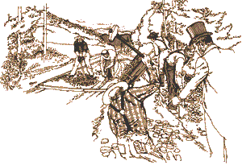

The National Road was built with rocks and gravel broken by hand and laid in trenches. It was the first highway built entirely with federal funds. The road was authorized by Congress in 1806 during the Jefferson Administration. The route closely paralleled the military road opened by George Washington and General Braddock in 1754-55.

**Early Construction**

Construction began in Cumberland, Maryland in 1811. By 1818 the road had been completed to the Ohio River at Wheeling, which was then in Virginia. Eventually the road was pushed through central Ohio and Indiana reaching Vandalia, Illinois in the 1830's where construction ceased due to a lack of funds. The National Road opened the Ohio River Valley and the Midwest for settlement and commerce. The National Road linked the eastern and western states in the first half of the 19th century, running from Cumberland, Maryland to Vandalia, Illinois.

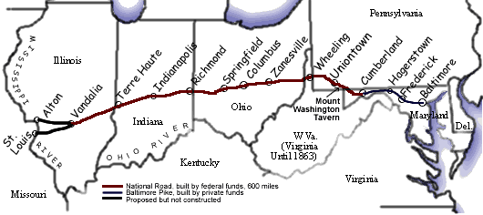

**Economic Impact**

The opening of the National Road saw thousands of travelers heading west over the Allegheny Mountains to settle the rich land of the Ohio River Valley. Small towns along the National Road's path began to grow and prosper with the increase in population. Towns such as Cumberland, Uniontown, Brownsville, Washington and Wheeling evolved into commercial centers of business and industry. Uniontown was the headquarters for three major stagecoach lines which carried passengers over the National Road. Brownsville, on the Monongahela River, was a center for steamboat building and river freight hauling. Many small towns and villages along the road contained taverns, blacksmith shops, and livery stables.

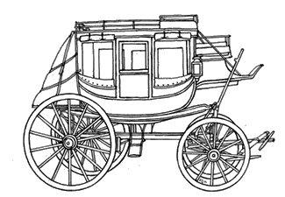

Stagecoaches were the fastest mode of transportation in the National Road era. Taverns were probably the most important and numerous business found on the National Road. It is estimated there was about one tavern every mile on the National Road. There were two different classes of taverns on the road. The stagecoach tavern was one type. It was the more expensive accommodation, designed for the affluent traveler. Mount Washington Tavern ([click here](https://www.nps.gov/places/the-mount-washington-tavern.htm)) was a stagecoach tavern. The other class of tavern was the wagon stand, which would have been more affordable for most travelers. A wagon stand would have been similar to a modern "truck stop." All taverns regardless of class offered three basic things; food, drink, and lodging.

Source: This material was adapted from [Traveling the National Road](https://oercommons.org/courses/traveling-the-national-road), provided by the National Park Service to OER Commons. Used under a Public Domain Dedication license.