# Practice Alt Text

Follow these steps to start adding alt text to images:

1. Imagine the image below in a digital document that a middle school social studies teacher creates on the topic of national monuments. In the document narrative, the teacher includes the quote that appears in the image but does not otherwise provide a description of the image’s content. What is appropriate alt text for the image?
2. As you develop alt text for this image, consider the following general best practices:
   1. Alt text should address both the content of the image and its function in the context of the information presented in the document.
   2. Text embedded in an image is not included in alt text if that text is presented in the body of the document.
   3. Alt text should be limited to about 150 characters.
3. Follow these steps to add alt text to **Figure 1** (“Practice Alt Text”):
   1. Select the image. In the **Picture Format** tab, click the **Alt Text** button. (Shortcut: Right-click on the image and choose “View Alt Text…”) The **Alt Text panel** opens.
      1. In the **Description** field, note the suggested alt text. This is automatically generated and frequently incorrect. Only check the “Approve alt text” box beneath the Description field if you are confident in the accuracy of the automatically generated description.
      2. Also, in this case example, the “Mark as decorative” option is not appropriate because the teacher does not visually describe the photo in the body of the text (with exception of the quote).
   2. Enter your alt text in the **Description** field. Note that there is no “OK,” “Apply,” “Save,” or other button to confirm your entry. However, when you close and reopen the Alt Text panel, you’ll see your entry remains.
4. Follow step 3a above to view the sample alt text provided for **Figure 2**. How does this sample alt text compare with yours?
5. Note the “Ideas that Work” logo on the last page. Click the image to view the alt text. Do you agree with the selected description?
6. Go to Microsoft Support for more [instructions on how to add alt text to a shape, picture, chart, SmartArt graphic, or other object](https://support.microsoft.com/en-us/office/add-alternative-text-to-a-shape-picture-chart-smartart-graphic-or-other-object-44989b2a-903c-4d9a-b742-6a75b451c669#PickTab=Microsoft_365).

Figure 1: Practice Alt Text (Steps 1-3)

Figure 2: View Sample Alt Text (Step 4)

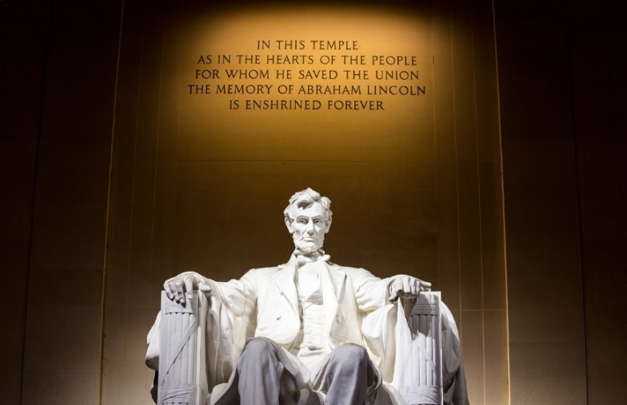

The contents of this document were developed under a cooperative agreement with the U.S. Department of Education, Office of Special Education Programs (Award No. H327Z240007). However, those contents do not necessarily represent the policy of the Department of Education, and you should not assume endorsement by the Federal Government. Project Officer: Rebecca Sheffield, Ph.D.

This work is licensed under a [Creative Commons Attribution-ShareAlike 4.0 International license](http://creativecommons.org/licenses/by-sa/4.0/).