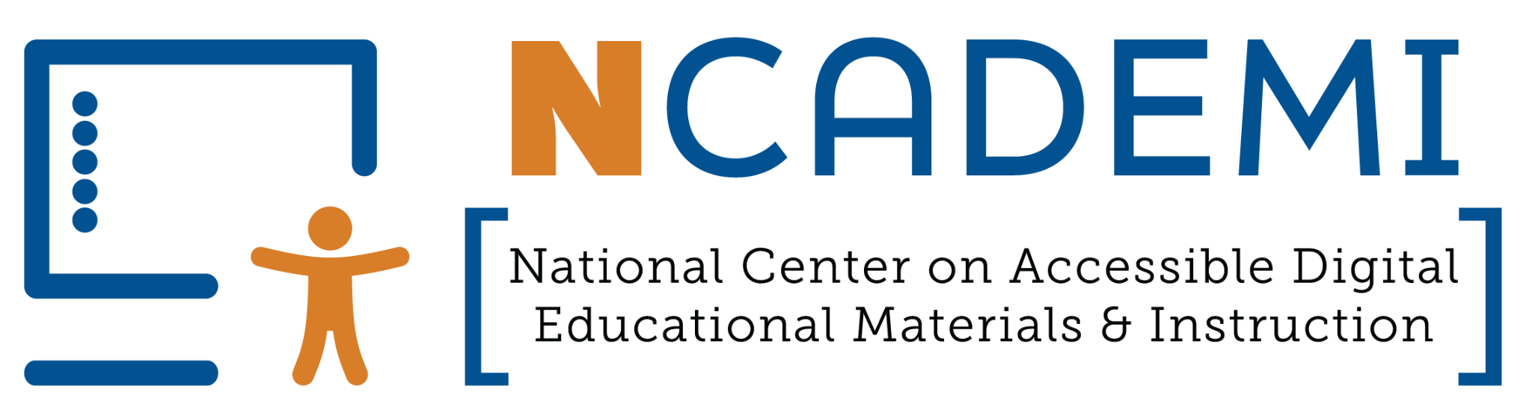

ADA Title II Roadmap & Quality Indicators Crosswalk
This resource connects the Quality Indicators for Accessible Digital Materials (DM) to the three tiers of the ADA Title II Roadmap, helping agencies see how implementation actions align across both frameworks.

Roadmap Tier One — Establish Foundations & Governance
Tier One activities are the most urgent, focusing on mobilizing leadership, communicating internally and externally, addressing the inaccessibility of current technology, and preventing inaccessibility of future technology.
- Establish a cross-disciplinary steering committee
  - DM1: Leadership Commitment
    - DM1.1 Steering Committee
- Communicate both internally and externally
  - DM7: Sustainability (Planning Phase)
    - DM7.2 Internal Communication Strategy
    - DM7.3 External Communication Strategy
    - DM7.4 Dissemination Strategy
- Create an inventory of all digital materials and technology products
  - DM6: Data Collection & Use (Early Stage)
    - DM6.1 Inventory of EdTech Accessibility
- Address accessibility in purchasing decisions
  - DM2: Guidelines for Accessibility in Procurement
    - DM2.1 Accessibility in Procurement Processes

Roadmap Tier Two — Evaluation, Policy, and Professional Development
Tier Two introduces activities that focus on developing policies and procedures, training, and professional learning.
- Evaluate for accessibility
  - DM2: Guidelines for Accessibility in Procurement
    - DM2.2 Vendor Demonstration Requirement
    - DM2.3 Accessibility Evaluation
- Adopt a digital accessibility policy
  - DM1: Leadership Commitment
    - DM1.2 Statement of Commitment
  - DM2: Guidelines for Accessibility in Procurement
    - DM2.1 Accessibility in Procurement Processes
  - DM3: Guidelines for Accessibility of Educator-Selected Digital Materials
    - DM3.1 Website Guidelines
    - DM3.2 Document Guidelines
    - DM3.3 Application Guidelines
    - DM3.4 Multimedia Guidelines
  - DM4: Guidelines for Accessibility of Educator-Created Digital Materials
    - DM4.1 Educator-Created Guidelines
    - DM4.2 Approved Content Creation Tools
    - DM4.3 Content Creation Guidelines
- Initiate ongoing role-based training and professional learning opportunities
  - DM5: Professional Development and Technical Assistance
    - DM5.1 Professional Development Includes Digital Accessibility
    - DM5.2 Role-Specific Training
    - DM5.3 Accessible Training Materials
    - DM5.4 Leverage Existing Training Resources
    - DM5.5 Training Material Repository
    - DM5.6 Designated Support Role

Roadmap Tier Three — Implementation, Feedback, and Sustainability
Tier Three focuses on ensuring long-term success by developing an implementation plan, revising job descriptions, budgeting for accessibility, and collecting feedback.
- Draft and maintain an organizational implementation plan
  - DM7: A Sustainability Plan
- Review job descriptions for accessibility responsibilities
  - DM1: Leadership Commitment
    - DM1.3 Clear Role Expectations
- Identify needed investments and prepare to budget for them
  - DM7: A Sustainability Plan
    - DM7.5 Resource Allocation
- Get feedback on progress
  - DM6: Data Collection and Use
    - DM6.2 Student Feedback
    - DM6.3 Family Feedback
    - DM6.4 Educator Feedback
  - DM7: A Sustainability Plan
    - DM7.1 Routine Self-assessments



The contents of this resource were developed under a cooperative agreement with the U.S. Department of Education (Department), Office of Special Education Programs (Award No. H327Z240007). The Department does not mandate or prescribe practices, models, or other activities described or discussed in this document. The contents of this resource may contain examples of, adaptations of, and links to resources created and maintained by another public or private organization. The Department does not control or guarantee the accuracy, relevance, timeliness, or completeness of this outside information. The content of this resource does not necessarily represent the policy of the Department. This publication is not intended to represent the views or policy of, or be an endorsement of any views expressed or materials provided by, any Federal agency. Project Officer: Rebecca Sheffield, Ph.D.
This work is licensed under a Creative Commons Attribution-ShareAlike 4.0 International license. https://creativecommons.org/licenses/by-sa/4.0/

