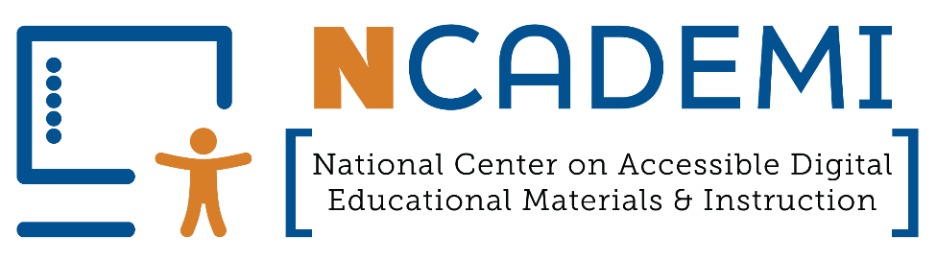

Coordinating a Team to Implement the Quality Indicators
Cross-disciplinary leadership is essential to systemic change in educational agencies. Working toward continuous improvement in digital accessibility involves critical perspectives from across the system. Quality Indicator DM1.1 and Quality Indicator AF1.1 outline the range of roles and responsibilities needed to create and sustain the provision and use of accessible materials in schools.
This resource is meant to help early initiators identify and coordinate members of a steering committee to lead implementation of one or both sets of Quality Indicators. Use it as is or adapt it to meet your needs. Please provide feedback to NCADEMI at ncademi@usu.edu.

Instructions
The table below includes the roles listed under Quality Indicator 1.1, Steering Committee, for both the Accessible Digital Educational Material (DM) and Accessible Format (AF) Quality Indicators. The “Related QI” column indicates which set applies to each role. Use the “Related QI” column as a reference and make your own independent determination of what roles are relevant based on your setting and context. Enter the name and email address of the individuals that represent each role. In some cases, multiple individuals might represent the same role. Use your best judgement to determine if all of them should be included or if it’s appropriate to identify one.
Compose a message to send to each individual. While you may not be ready to propose a steering committee, this is an opportunity to start a conversation with the people in your setting who have an important role in improving the accessibility of materials provided to students in your state or district. Two sample emails are provided as starting points.
Track responses to your email in the “Response” column and next steps in the “Follow-Up” column.

Role Needed | Related QI | Name | Email | Response | Follow-Up
Administration from general education | DM
Administration from special education | Both
Technology (education, information, instruction, and assistive) | Both
General education | Both
Special education and related services | Both
Assessment | Both
Instructional materials adoption | Both
Curriculum and instruction | DM
Procurement | Both
Finance | DM
Data management | AF
Staff and community members with disabilities | DM
Students with disabilities and their parents or caregivers | Both
NIMAC State Coordinator (State level) | AF
AT Act Program representative (State level) | AF
State Parent Center representative (State level) | AF

Sample Emails
We recommend sending emails to individuals for better engagement and opportunity for personalization. Add a brief note about why this specific person or role would bring a valuable perspective. Be sure to follow up if you don’t hear back.

Email 1: Raising awareness
Copy, paste, and personalize this message if accessibility isn’t yet being addressed in your setting.
Subject: Resource to improve the accessibility of our educational materials
Hi [Name],
I’ve been learning about the barriers that educational materials can create for students with disabilities who use assistive technology and universal accessibility tools. The good news is there are actions we can take to improve the accessibility of the materials provided to our students.
Given your important role, I wanted to make sure you’re aware of two new sets of Quality Indicators that outline how we can ensure students with and without disabilities can use their learning materials. The Quality Indicators for Accessible Digital Educational Materials help agencies like ours address accessibility in procurement and in the digital materials educators select and create. They are aligned with the recent update to Title II of the Americans with Disabilities Act, which you may already know about.
The Quality Indicators for Accessible Formats outline how to ensure students with disabilities who need accessible formats (e.g., braille, digital text, audio, large print) receive them by the start of instruction. They are aligned with the Individuals with Disabilities Education Act (IDEA) and are ideal for special education leadership and IEP teams.
Please take some time to review the Quality Indicators and let me know your thoughts about their potential as a resource for us. From my perspective, they can help us target improvements in the accessibility of the materials being provided to students.
If I don’t hear back from you within a week or so, I’ll follow up as a courtesy. I’m sharing this information with others and will coordinate next steps based on feedback.
Thank you,
[Your Name]

Email 2: Recruiting a Team
Copy, paste, and personalize this message if progress is already being made in your setting, but it’s not yet coordinated by a cross-disciplinary team.
Subject: Quick Conversation About a New Accessibility Leadership Effort?
Hi [Name],
I’m reaching out because we’re assembling a team to strengthen how we approach accessible formats and digital accessibility [select one or both] to improve access to learning for students with and without disabilities. This effort will benefit from perspectives across instruction, curriculum, technology, assessment, procurement, and leadership, and your perspective would be especially valuable.
Before anything formal, I’d love to schedule a brief conversation to share what we’re hoping to accomplish along with some resources and get your initial thoughts. From there, we can plan appropriate next steps.
Would you be open to finding a few minutes sometime this week or next?
Thanks so much,
[Your Name]


The contents of this resource were developed under a cooperative agreement with the U.S. Department of Education (Department), Office of Special Education Programs (Award No. H327Z240007). The Department does not mandate or prescribe practices, models, or other activities described or discussed in this document. The contents of this resource may contain examples of, adaptations of, and links to resources created and maintained by another public or private organization. The Department does not control or guarantee the accuracy, relevance, timeliness, or completeness of this outside information. The content of this resource does not necessarily represent the policy of the Department. This publication is not intended to represent the views or policy of, or be an endorsement of any views expressed or materials provided by, any Federal agency. Project Officer: Rebecca Sheffield, Ph.D.
This work is licensed under a Creative Commons Attribution-ShareAlike 4.0 International license. https://creativecommons.org/licenses/by-sa/4.0/

